INFOPACK
FOR YOUTH EXCHANGE

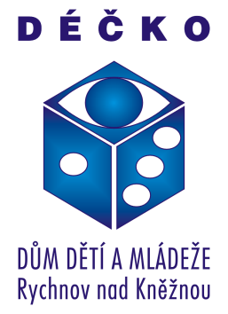
29.07-05.08.2017
DEŠTNÉ V ORLICKÝCH HORÁCH, CZECH REPUBLIK

Our project
The project is coordinated by Déčko-DDM Rychnov nad Kneznou and funded by Erasmus+ through the National Agency of Czech Republic.
The project will start July 29th at 13:00 and will end August 5th around 11:00. In this project will partake people from Czech Republic, Greece, Latvia, Lithuania, Germany, Bulgaria and Poland, in all together there will be 37 participants.
Main goals of this youth exchange are:
- to form tolerance and openness, to provide better understanding of people from different cultures, especially situation of refugees
- to encourage young people to overcome the fear of the unknown things and failure, to increase their self-confidence
- to increase awareness of youth of learning by daily experience
- to develop their creativity and to improve dancing, acting and artistic skills
- to promote innovative methods in youth work
- to create a fairy-tale movie about the Hero’s journey

The youth exchange
The youth exchange is going to take part in Czech Republic. 29 young people and 8 youth leaders will have the chance to create together a short movie about Hero’s journey.
Profile of participants
Participants will be young people 14-27 years old (preferably 17-20 y.o.) that are interested in acting and dancing activities as well as interested in this topic about refugees. Participating countries will have 4 young people and 1 leader.
Profile of leaders
Leaders have no age limit but are expected to be highly motivated in helping and contributing to everyday activities, evaluation and dissemination results.
Accommodation
The project is going to take part in Deštné v Orlických horách 105, 50 km eastern from Hradec Králové. Itis going to be hosted byPenzion Anička (www.penzionanicka.cz).

Preparations for project
We want to ask you to take with you your countries traditional food for national evenings;we suggest that you bring sweets or cookies since it isn’t possible to cook also you could bring some traditional drinks. Also please think about how you would present your country and its traditions.
Also you need to take with you your team’s favourite traditional fairytale in a DVD or CD.

Tickets
For people who plan to travel with trains, international bus lines or airplanes, we suggest to buy the tickets till 20th of June, as well as to send us the ticket copies till 20th of June. We imply you to contact and consult with us before buying tickets as well you will have to receive our agreement. Also please take into consideration your arrival time, since the project will start at 13:00.
For people who plan to travel via other means – please contact us directly.
Contacts
For any questions or details please don’t hesitate to contact us at:
deckorychnov@gmail.com
You can also ask your questions in our facebook page. (https://www.facebook.com/groups/598773626987852/)
In case of emergency you should contact the project coordinator, Josef, at +420 777 423 686

See You soon!

